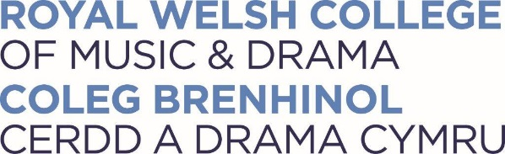
Community Music Lessons
Application Form

Thank you for your interest in the Community Music lessons. Please complete this form and send it, with a cheque for the relevant fee (see below) made payable to ‘RWCMD’ to: The Junior Conservatoire, RWCMD, Cathays Park, Cardiff, CF10 3ER.

We will write to confirm receipt of your application, and contact you normally within 6 weeks with details of your consultation date and time.

Please note that in general lessons are given on a Saturday. Applicants wishing to study piano must have access to an acoustic instrument at home.

What to expect at your consultation:
We will do our utmost to ensure that your consultation is a friendly and positive experience. Two people will listen to you, the Head of the Junior Conservatoire and a specialist on your instrument. You should prepare the following:
two contrasting pieces/songs of your own choice (if you are a complete beginner, your audition will include pitch and rhythm tests)
aural exercises may also be asked
a discussion, during which you will be asked about your musical aspirations and other interests

If the applicant is under 18, the entire form must be completed by a parent/carer

Applicant’s Personal Details
Surname: | First Name(s)
Date of birth (if applicant is under 18):
Address for all communications:
County: | Postcode:
Home tel number: | Mobile number:
Email address: | Emergency contact number:
Full names of Parents/Carers (if applicant is under 18)

The consultation fee (non-refundable) for Community Programme: Music Lessons can be found on the website
I enclose a cheque made payable to RWCMD (please call 029 20391365 to pay by an alternative method)

If in full-time education
Name of School/College:
School Year (as at 1st September of calendar year of application):

Important Information
Do you have a disability or any special needs? (please specify)
Do you have any special requirements? (please specify
About your experience
What is the Principal Study Instrument/Voice you wish to audition for? (please state)_____________________
Are you a beginner: Yes/No
Grade achieved_____________ Mark_____________ Date passed_____________ Exam Board______________
When did you start learning this instrument? ______________________________________________________
What is the name of current teacher? ____________________________________________________________
Where do you have your lessons (please tick)?
a) In school (independent) ☐ b) With a hub (or equivalent), music service or in a state school ☐
c) Specialist music school ☐ d) Private tuition ☐
Do you require a College accompanist for your audition? Yes/No
Have you taken an ABRSM theory exam?
If yes, please state the most recent grade, mark and date taken:
GCSE / AS / A LEVEL MUSIC (if applicable):
Grade achieved:_____________ | Mark: ________ | Date passed:_________ | Exam Board:_________

Please tick if you require tuition of 30 minutes, 45 minutes or 1 hour a week (or other). For lesson cost please see the website. Minimum amount of tuition is 5 X 30 mins per term.
30 minutes |  | 45 minutes |  | 1 hour

How did you hear about us?
Welsh Language
Do you speak Welsh?  If Yes, would you like to receive communication in Welsh? | YES/NO  YES/NO | If you are Welsh speaking, would you be interested in exploring opportunities for learning and teaching through the medium of Welsh? | YES/NO
Privacy Statement
The College takes the protection of all personal information seriously and is fully committed to the protection of the rights and freedoms of all individuals. We will process your data according to our privacy statement, which you can read at www.rwcmd.ac.uk/privacy

Signed (by applicant and Parent/Carer if under 18)

Date

